**Normal Distribution**

The **normal distribution**is defined by the following probability density function, where *μ*is the population [mean](http://www.r-tutor.com/node/35) and *σ*2 is the [variance](http://www.r-tutor.com/node/42).

f(x) =-√1--e-(x-μ)2∕2σ2
      σ  2π


If a random variable *X*follows the normal distribution, then we write:

          2
X ~ N (μ,σ )


In particular, the normal distribution with *μ*= 0 and *σ*= 1 is called the *standard normal distribution*, and is denoted as *N*(0*,*1). It can be graphed as follows.

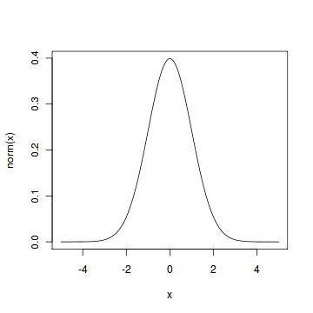

The normal distribution is important because of the **Central Limit Theorem**, which states that the population of all possible samples of size *n*from a population with mean *μ*and variance *σ*2 approaches a normal distribution with mean *μ*and *σ*2*∕n*when *n*approaches infinity.

#### Problem

Assume that the test scores of a college entrance exam fits a normal distribution. Furthermore, the mean test score is 72, and the standard deviation is 15.2. What is the percentage of students scoring 84 or more in the exam?

#### Solution

We apply the function pnorm of the normal distribution with mean 72 and standard deviation 15.2. Since we are looking for the percentage of students scoring higher than 84, we are interested in the *upper tail*of the normal distribution.

> pnorm(84, mean=72, sd=15.2, lower.tail=FALSE)   
[1] 0.21492

#### Answer

The percentage of students scoring 84 or more in the college entrance exam is 21.5%.